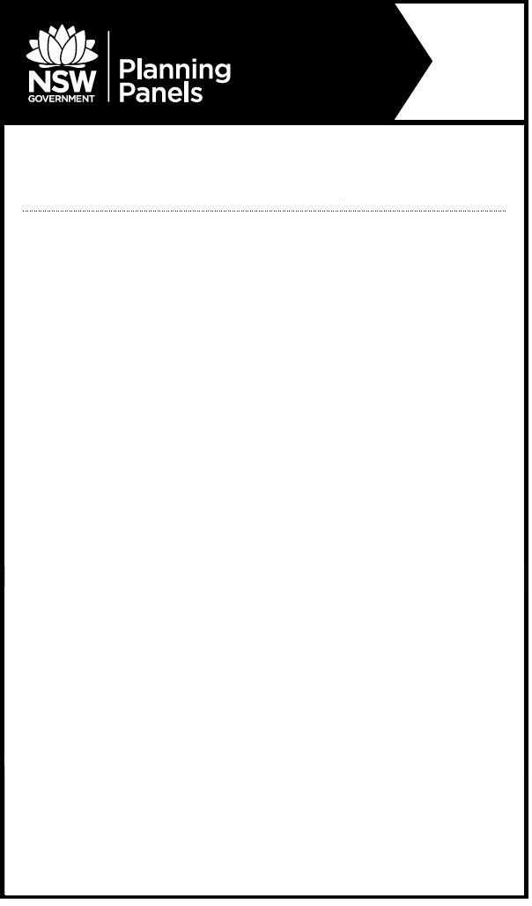

**Audio Recording of Panel Meeting**

**2016WES006 – Dubbo - PP_2016_DUBBO_005_03**

Daisy Hill, Dubbo

Amendment to Dubbo LEP 2011 - To reduce the minimum lot size of land in zone R5 Large Lot Residential to facilitate the creation of 284 lots with a range of minimum lot sizes, of 6000m2, 1.5ha and 3ha at land known as Daisy Hill, Dubbo

The meeting was held:

**When:** Tuesday 9 June 2020 at 10.30am

**Where:** via teleconference

[**CLICK HERE**](https://soundcloud.com/user-645092504/western-regional-planning-panel-dubbo-2016wes006-9-june-2020) **for the audio file of the above meeting.**

**For more information:** (02) 8217 2060